Hello Team.

Done by best with two tasks.

Task 1: Unable to process the Google authentication, Hence prepared Hello World flask app with time zone which is virtually activated. But even though with no errors and installed and imported all necessary libraries, still not able to view the time zone, I would request to let me know where did I go wrong.

Screenshot of task 1:

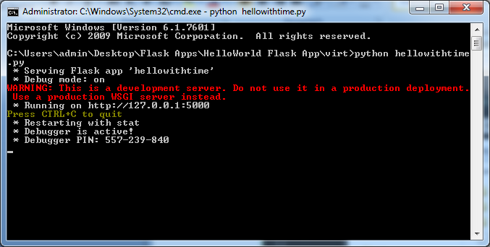

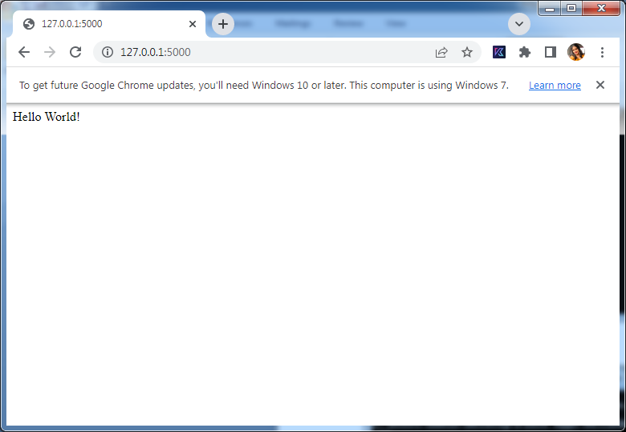

Task 2:

It was my incomplete pattern yesterday, but today I did it with string given, but the confusion I found over here is how to process the complete continuous string. Here’s the Output received.

Screenshot of task 2:

